INTRODUCTION;

Public sector banks have been merged by the government in the last few years. This is the rationale behind conducting this study. The purpose of this article is to determine the factors affecting the performance of public sector banks in India and the interrelationship between bank-specific determinants and performance of public sector banks. In this article, we shall analyse the financial data of all the public sector commercial banks for a period spread across 11 years (2009–2019); Capital adequacy, Assets quality, Management efficiency, Earning, and Liquidity (CAMEL) has been used as a performance determinant; system generalised method of moments (GMM) analysis has been used to find the effect of determinants on the performance measurement of public sector banks; and CCA (canonical correlation analysis) has been used to find the interrelationship between the bank-specific determinants and the performance of public sector banks. The finding has important implications in terms of performance in the banking sector. Certain limitations of this study are: It is based on secondary data. The study only covers the financial aspects and not the non-financial aspects. It is found that the asset quality is negatively related with performance of public sector banks. Liquidity and inflation are inversely related to performance of public sector banks in India. Capital adequacy is positively related with banks’ performance, but inversely

PURPOSE

Following the successful completion of this session, you should be able to: • recognize the basic balance sheet accounts and income statement components and understand how they relate to each other • apply the ROE model to analyzing bank profitability over time and against peers • comprehend the importance of net interest margin, earning assets, and operating efficiency as sources of bank profitability • identify key ratios that signify the degree of credit risk, liquidity risk, interest rate risk, and capital risk assumed by a bank • explain the factors that affect a bank's CAMELS rating • understand how and why the performance characteristics of small and large banks differ • relate key financial concepts and data to planning and managing a bank.

EMPATHY MAP: 

IDEATION AND BRAINSTORMING MAP:

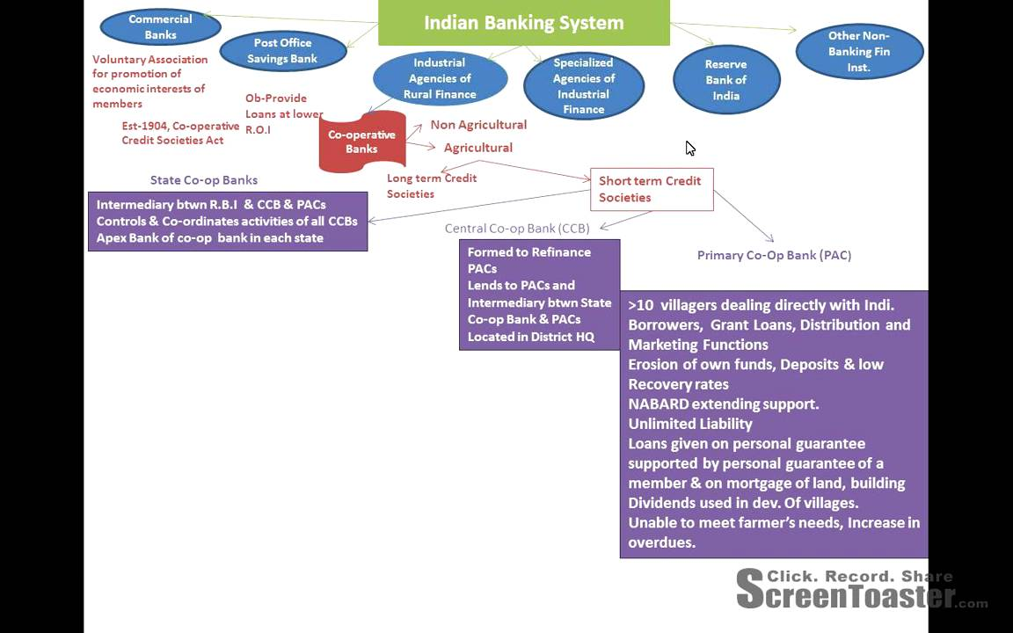

RESULT:

Banks have access to a variety of financial resources, including:

1. Deposits: Banks accept deposits from their customers, which are the most important source of funding for banks. Deposits can be in the form of savings accounts, checking accounts, time deposits, and other types of accounts.
2. Loans: Banks lend money to individuals and businesses, and the interest they earn on these loans is another source of funding. Banks can also invest in bonds, stocks, and other financial instruments.
3. Borrowings: Banks can also borrow funds from other financial institutions or the central bank. This is usually done in times of liquidity shortage or to meet regulatory requirements.
4. Equity: Banks can also raise funds by issuing shares of stock.
5. Reserve requirements: Banks are required to maintain a certain percentage of their deposits as reserves with the central bank. These reserves can be used in case of emergencies.
6. Interbank lending: Banks can also lend to each other in the interbank lending market. This is done to manage liquidity and to balance their books.

Overall, banks have a variety of financial resources to manage their operations and provide services to their customers.

ADVANTAGES OF FINANCIAL RESOURCES OF BANK:

Pros:

1. Provides the necessary funding for business expansion and growth.
2. Enables businesses to invest in research and development, leading to innovation and new products/services.
3. Allows businesses to take advantage of opportunities in the market that require capital investment.
4. Helps businesses survive economic downturns and unexpected crises.
5. Provides the cash flow necessary to pay bills, debts, and operating expenses.

DISADVANTAGES OF FINANCIAL RESOURCES OF BANK:

1. Acquiring financial resources can be time-consuming and require a lot of paperwork, documentation, and negotiations with lenders.
2. The cost of borrowing can be high, resulting in additional costs and interest payments that may hurt the business's profitability.
3. Financial resources can create an overreliance on external funding, reducing the business's ability to grow organically.
4. Failure to repay loans or meet financial obligations can damage a business's credit rating and result in legal action.
5. Financial resources can be limited, forcing businesses to choose between competing priorities and investments.

APPLICATIONS:

1. Emergency funds - having a contingency fund can help mitigate financial risks in case of unexpected job loss, health expenses or other unforeseeable financial emergencies.
2. Insurance - purchasing insurance policies can transfer the risk of financial damages from accidents or unexpected events to an insurance provider, giving you financial protection.
3. Diversification of investments - spreading investment holdings across different assets and industries can help reduce the risk exposure of individual investments.
4. Professional advice - seeking advice from financial experts such as financial advisers, accountants, or lawyers can help mitigate risks by ensuring that your financial decisions are sound.
5. Continuous learning - keeping yourself informed about the changing financial landscape, economic trends and regulations can help you anticipate potential risks and make informed decisions.

CONCLUSION:



Financial resource is a very important resource which an organization needs not only for its functioning  but also for its sustained success. For this purpose the organization need to have systems in place that help it to both fund its ambitions and also to manage its financial resources in support of its daily operations, including funding for improvement activities.

Normally financial controls are applied by the management which enable it to take a proactive management position in the business. The three most important financial controls are namely (i) the balance sheet, (ii) the profit and loss statement, and (iii) the cash flow statement. But the management of financial resources is much more than the exercising of the financial controls.

The management of the financial resources is an important function of the management in the organization. This financial management starts with the financial planning. Financial planning is a continuous process of directing and allocating financial resources to meet strategic goals and objectives. The output from financial planning normally takes the form of budgets.

FUTURE SCOPE:

1. **Investment Decisions**

Financial managers are responsible for choosing the right investment choices for the business.

There are two types of investment decisions, namely, long-term and short-term. Long-term investment decisions include capital budgeting. Capital budgeting is a process which includes the company’s decision to invest in fixed assets.

On the other hand, short-term investment decisions include the company’s funds invested in current assets. Therefore, financial management includes decisions like inventory planning, bank deposits, and other short-term investments.

1. **Financing Decisions**

Another critical business decision that comes under the scope of financial management is the financing decision. Finance management is responsible for two different types of financing decisions- financial planning decisions and capital structure decisions.

Financial planning decisions include identifying the sources of income and investing in them to increase the companies’ fixed assets. On the other hand, capital structure decision identifies various sources of fund.

Financial managers play a vital role in this business decision- from finding investors for continuous funding to designing the capital structure, they do all the roles and responsibilities of financial planning and execution.

1. **Dividend Decisions**

Financial managers decide the profit distribution model of the company. They decide whether the shareholders will get their profits through dividends or retained profits.

Finance management’s scope is not limited to paying out dividends. It (FM) also plays a critical role in making decisions related to a company’s profit. For instance, FM is responsible for determining what percentage of profit should be considered as retained earnings.

***Note:*** *Retained earnings are a part of the company’s cumulative profit that is saved for the future.*

1. **Liquidity Decisions**

Liquidity is the availability of assets that can be easily converted into cash. Finance managers consciously make investment decisions to ensure that the company’s assets can be liquidated and profitable in any market condition.





SORCE CODE :

Code    Description  
01 – Regular Agency Fund  
02 – Foreign Assisted Projects Fund  
03 – Special Accounts – Locally Funded/Domestic Grants Fund  
04 – Special Accounts – Foreign Assisted/Foreign Grants Fund  
05 – Internally Generated Funds  
06 – Business Related Funds  
07 – Trust Receipts.